P-ROC Connections for Judge Dredd

This visual guide shows how to install a P-ROC board in a Judge Dredd pinball machine. The [connector mappings](https://www.multimorphic.com/content/uploads/2017/08/P-ROC_Connector_Mappings_v2.pdf) published by Multimorphic are the official instructions. The way to read the table is: unplug the WPC connector J??? and move it to P-ROC location J??.

The CPU board in Judge Dredd is WPC DCS. The connections are different if you have a WPC secure or WPC95 machine. It could even be different for other WPC DCS machines.

J208 and J209 are the same pin for pin. J208 is normally absent but connect it if it’s present.

Judge Dredd Backbox

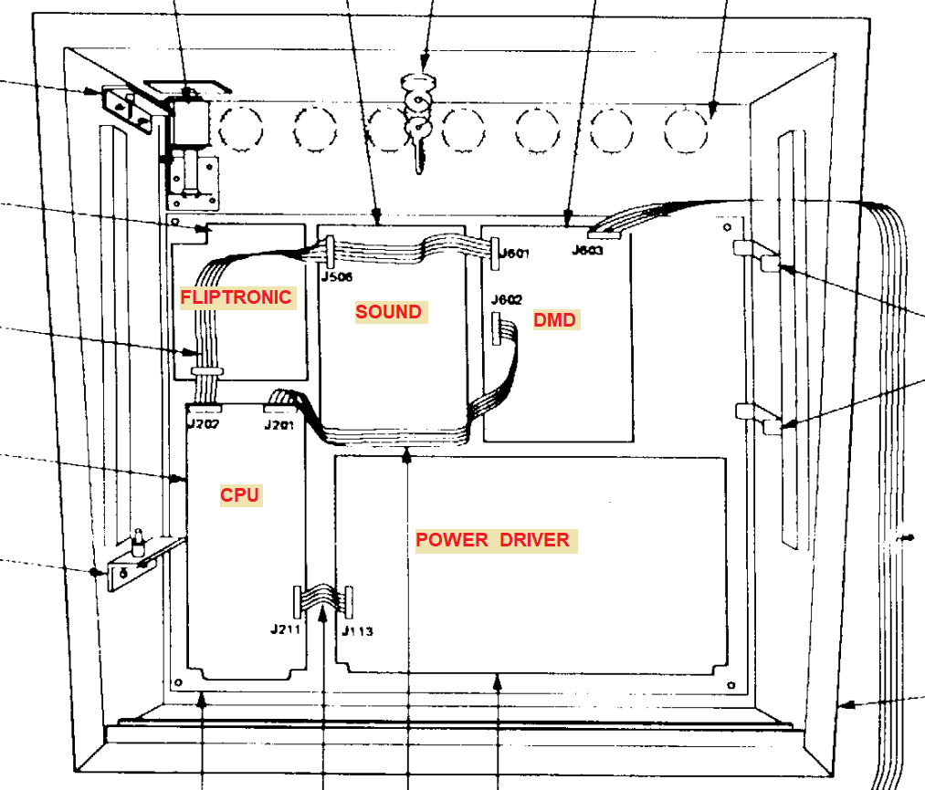

P-ROC board

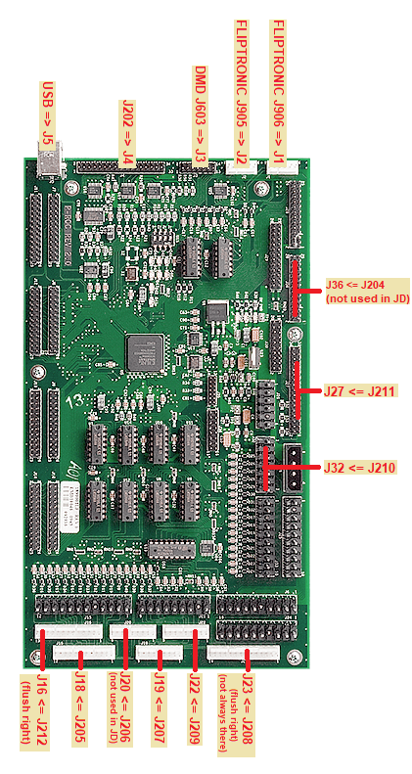

Fliptronic Board

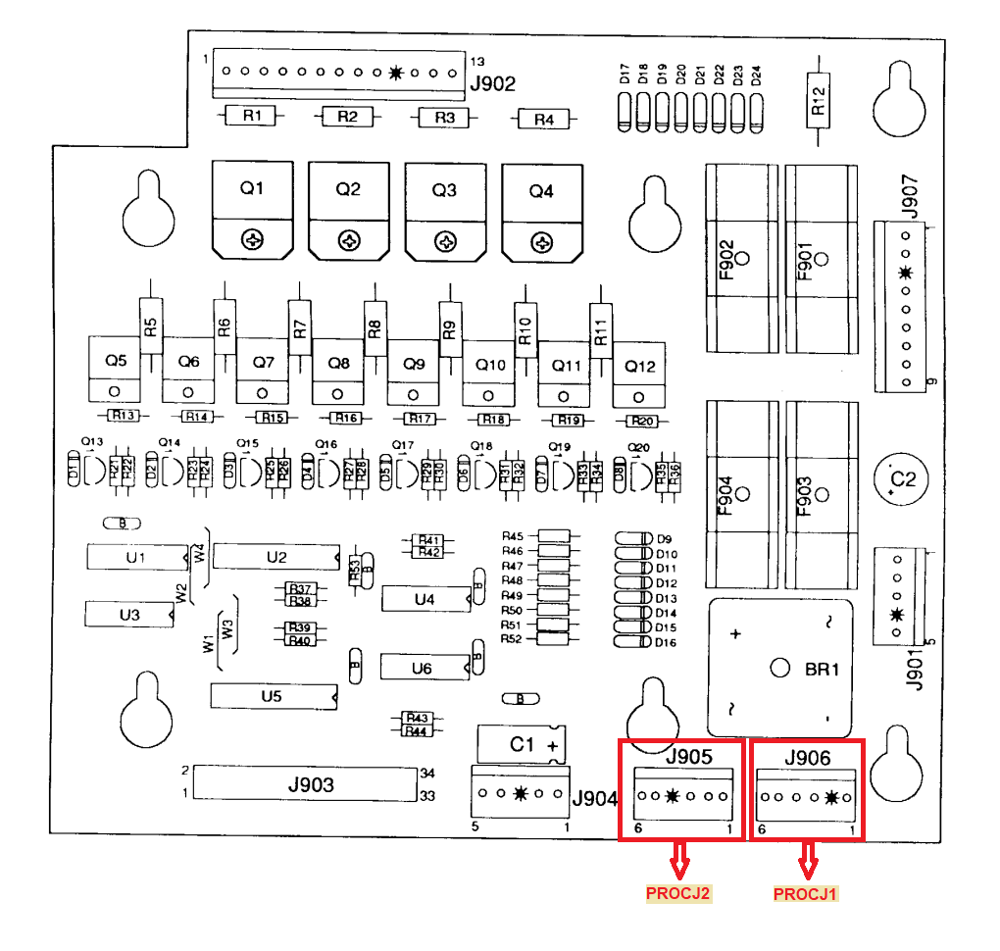

DMD Board

Move J603 connector to P-ROC J3

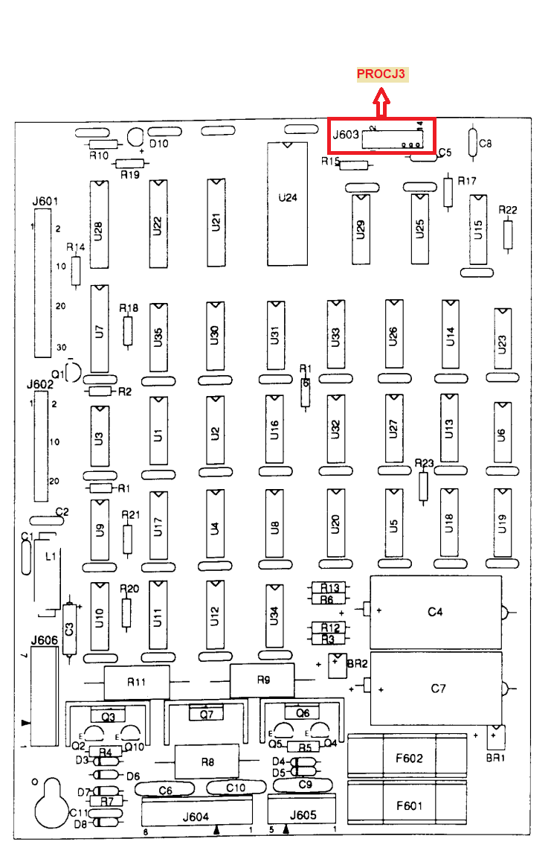

CPU Board

Connectors J204, J206 and J208 are not used in JD.

They are shown here for completeness with other WPC machines.

